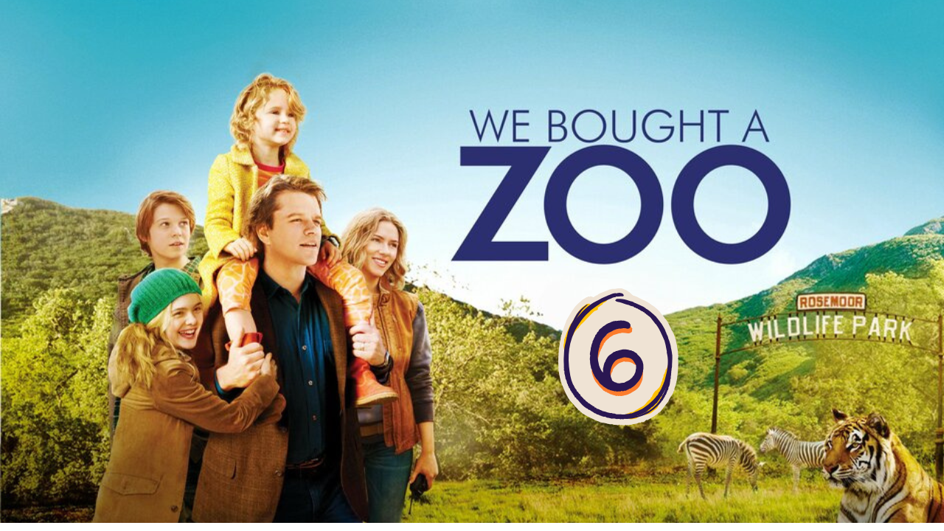
“We Bought a ZOO” (Scene 06)

Work on Scene 01

- Scene events summary:

At the beginning of the scene, Benjamin, the inexperienced zoo owner, discusses urgent problems with the staff. Spar, an aging tiger, needs special care, and a costly vet from San Diego. The zoo has several other issues, including weak enclosures and sick animals. Benjamin learns that the zoo community calls cages "enclosures" and is questioned about his decision to buy the zoo. Kelly, a dedicated worker, expresses frustration over staff quitting and financial struggles. Meanwhile, Benjamin’s brother sarcastically suggests abandoning the zoo to focus on Kelly instead. Despite doubts, Benjamin insists on continuing for his daughter, Rosie, who loves the zoo.

- Scene Discussion & Analysis:

- Q01: What was wrong with Spar?
Spar is an old tiger and it is difficult to take care of him.
- Q02: Did it cost too much to take care of him?
Yes , it did .
- Q03: Why did Kelly seem hesitant to make that investment?
- Kelly seemed hesitant to invest on Spar because there is a high chance he dies .
Q04: How are the animal cages in the ZOO officially called?
The cages are officially called enclosures .
- Q05: Based on your personal analysis, why they are no longer called “cages”?
- People are no more using the term cages because it carries a negative meaning that the animals are not taken care of . Besides , it doesn’t really describe where they are put as cages often are small . Instead , they are using the word enclosure to sound more human and it describes accurately the place of the animals as it is designed to be keen to the natural homes of the animals .
- Q06: Was Benjamin’s name known in the ZOO community?
No , it wasn’t .
- Q07: Did he have a good reason to buy the ZOO, though?
No , he didn’t .
- Q08: If not, what do you think made him take that risky decision in your opinion? (How would you analyze his decision?)
- The main reason that motivates Benjamin to buy the zoo was his daughter Rosie.
Q09: Did Kelly feel secure with Benjamin taking charge of the ZOO? Can you explain why (based on your understanding)??
Kelly doesn’t feel secure with Benjamin taking charge of the Zoo as he is just a random guy from the city who doesn’t know anything about the zoo or animals. Besides, she doesn’t trust his decisions relating to finance as he seems to agree on everything and doesn’t take a moment to make priorities.

- Acquired Vocabulary (OPTIONAL):

- To get along:
- Example in a sentence:
- They get along fine at work .
- To drill yourself into something: infernal
- Example in a sentence:
“With this project you drilled yourself into infernal problems “
- Pathetic (adj):
- Example in a sentence:
“ The team’s performance was so pathetic that the couch decided to hold extra practice sessions to improve their skills “
Docile (adj):
- Example in a sentence:
“ The docile students often are the best in their teacher’s eyes “

- Irregular Verbs:

Infinitive | Past simple | Past participle
To meet | Met | Met
To take charge | Took charge | Taken charge
To make | Made | Made

Additional Exercise (Optional)

Task: Transcribe sentences from the scene.
Transcribe Sentence 01
Spar who’s you just met the tiger he’s gonna need some special care so we have a large animal vet coming from San Diego .It’s just that a fortune to get here and that’s ok .
► Transcribe Sentence 02
I’m pathetic, I had to move back in with my mother . No one gets paid Ben – Jamin we need somebody who can really take charge of this place or else we and all these animals are gone.
Business Consultant – Entrepreneurial couch – Business Advisor

What I struggled WITH? (Optional)

.... .... .... .... .... .... ..... .... .... .... .... .... ..... .... .... .... .... .... ..... .... .... .... .... .... ..... .... .... .... .... .... ..... .... .... .... .... .... ..... .... .... .... .... .... ..... .... .... .... .... .... ..... .... .... .... .... .... ..... .... .... .... .... .... ..... .... .... .... .... .... ..... .... .... .... .... .... ..... .... .... .... .... .... ..... .... .... .... .... .... ..... .... .... .... .... .... ..... .... .... .... .... .... ..... .... .... .... .... .... ..... .... .... .... .... .... ..... .... .... .... .... .... ..... .... .... .... .... .... ..... .... .... .... .... .... .....

